Kenny S.

Asrar M.

Dr. Rachel A.

Modern Database Management

November 29, 2017

DBM Final Project Check List

**Creating tables**

CREATE TABLE MEMBERSHIP

(

MembershipID int,

Amount Decimal(6,2),

MembershipType VARCHAR(15)

)

CREATE TABLE STAFF

(

StaffID int,

Fname VARCHAR(20),

Lname VARCHAR(20),

PhoneNo VARCHAR(20),

Email VARCHAR(25),

Adress VARCHAR(30),

City VARCHAR(30),

Zipcode int

Primary key(StaffID)

)

CREATE TABLE EQUIPMENT

(

EquipmentID int,

Equipmentname VARCHAR(30),

ECondition VARCHAR(15),

LastInspection VARCHAR(20),

PurchaseDate VARCHAR(20)

Primary key(EquiptmentID)

)

CREATE TABLE CUSTOMER

(

CustomerID int,

Fname VARCHAR(20),

Lname VARCHAR(20),

PhoneNo VARCHAR(25),

Adress VARCHAR(30),

City VARCHAR(20),

Zipcode Int,

Email VARCHAR(35),

JoinDate VARCHAR(25)

Primary key(CustomerID)

)

CREATE TABLE PAYMENTINFO

(

CustomerID int,

MemID int,

LastPayment VARCHAR(20),

NextPayment VARCHAR(20),

PaymentInfo VARCHAR(35)

Primary key(CustomerID)

)

Result = the string the java methods returned to complete the SQL statements.

i.e(String result = staffID+", '"+first+"','"+last+"','"+phone+"','"+email+"','"+address+"','"+city+"',"+zipcode;)

1. For Inserting we used:
2. INSERT INTO STAFF VALUES(+result+)
3. INSERT INTO CUSTOMER VALUES(+result+)
4. INSERT INTO MEMBERSHIP VALUES(+result+)
5. INSERT INTO PAYMENT VALUES(+result+)
6. INSERT INTO EQUIPTMENT VALUES(+result+)
7. For Deleting we used:
   1. DELETE FROM STAFF WHERE StudentID = #
   2. DELETE FROM CUSTOMER WHERE CustomerID = #
   3. DELETE FROM MEMBERSHIP WHERE MembershipID = #
   4. DELETE FROM PAYMENT WHERE CustomerID = #
   5. DELETE FROM EQUIPTMENT WHERE EID = #
8. For Selecting we used:
   1. SELECT * FROM STAFF
   2. SELECT * FROM CUSTOMER
   3. SELECT * FROM MEMBERSHIP
   4. SELECT * FROM PAYMENT
   5. SELECT * FROM EQUIPTMENT
9. For the Joining we Used
   1. SELECT e.MembershipID,Amount,MembershipType,LastPayment,NextPayment

FROM Membership e, Payment d WHERE e.MembershipID=d.MembershipID

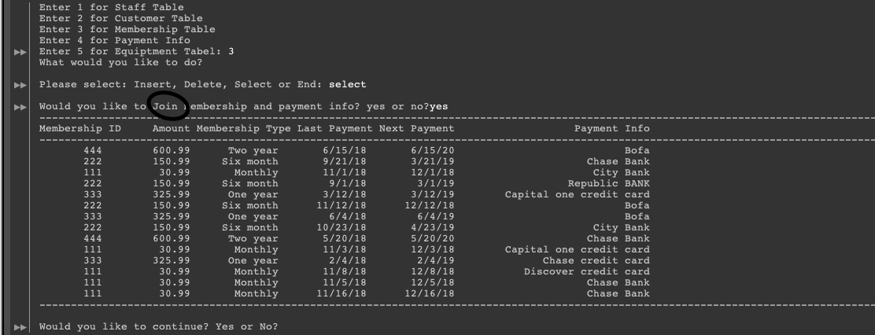

**View**

We created a view in the table PAYMENTINFO TO pull out customerID’S which has payment method BOFA (Bank of America)

CREATE VIEW BOFA_ACCOUNT_MEMBERS AS

SELECT CusID PaymentInfo

FROM PAYMENTINFO

WHERE PaymentInfo="Bofa"

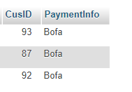

I have to know the due date for the person with CustomerID =98

CREATE VIEW Due AS

SELECT CusID, NextPayment

FROM PAYMENTINFO

WHERE CusID=98

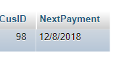

**Describing the project**

We have created a gym database which has five tables and their attributes as follows:

**Staff** (***StaffId,*** Fname, Lname,  PhoneNo, Email, Address, City, Zipcode)

**Customer** (***customerID,*** Fname, Lname, PhoneNo, Address, City, Zipcode, Email, JoinDate )

**PaymentInfo** (**customerID**, MembershipID, LastPayment, nextPayment, PaymentInfo)

**Membership** (**Membership Id**, Amount, Membership Type)

**Equipment** **(EquipmentId,** Equipment Name, Condition, Last Inspection, PurchaseDate)

Staff table has basic information about the staff, Customer table has similar sort of information, but it also has joined date added. Payment Info table has a foreign key as customer ID, membership ID and entities related to payment. If we have to pull out a payment Info on a customer, we just have to enter their customer Id and based on what their membership type is and their last payment date we can automatically get their next payment date. Membership table is simple, which has membership id, type and the amount for their membership type. Equipment table has Id, name and basic information related to the equipment.

We have created six java fives, five have them are tables and the methods to either insert, select or delete. We have one main method class, from where we access everything. When you first run the method, it gives you options to access any of the five tables. Once you select one of those, we then have to enter from the options what we would like to do. (Insert to the table, Retrieve, Delete or Join). If we chose to insert, we will have to enter all the values from the selected table. Similarly, for retrieve it will retrieve all the information from the selected table. You can also delete a row from selected table and then Join attributes across the tables.